Bussum, March 4th 2019

Strategic Plan for the year 2019

Dear Peace-lover,

Herewith we present you the Strategic Plan of Peace SOS for the year 2019. Peace SOS is established officially April 22nd 2016, Earth Day. We want a world in which all children can go to school and play. On contrary in 2017 approximately 85,000 children under age of 5 years died as a result of the war in Yemen from starvation between April 2015 and October 2018 according to aid organization Save the Children. Refugees are dying from the cold in refugee camps in Libanon.

At Peace SOS we do our best to stimulate peace by:
- Supporting local peace organizations. In 2019 we plan e.g. to help Burundian Women for Peace and Development with community radio in Burundi. And we support Minds of Peace who organizes public peace negotiations with people from Israel and people from the Westbank
- Listening to and talking with various parties (such as ambassadors, political opponents et cetera) involved in a war. We mention that we want a world in which all children can play. That we want a diplomatic solution for a war and humanitarian aid for the citizens. In 2019 Yemen will be one of the countries on which we focus.
- Writing publications and making videos. Based on talks with various parties and by studying documents of the United Nations and following the news, we are trying to come up with suggestions about how peace can be achieved in a peaceful way. We write publications and submit public opinion articles to Dutch national newspapers as well as blogs and online publications.
- Creating peace awaraness. For example by helping vulnerable people to raise their voice (such as the sisters @Noor_and_Alaa) and taking part in social media campaigns. Participating or organizing events.
For the organization of Peace SOS, the focus will be on attracting new volunteers and acquiring funding for our projects.

Greetings from the heart,
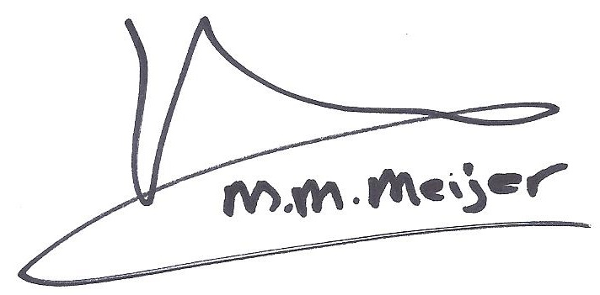
May-May Meijer
Chair of Peace SOS
Mission of Peace SOS

The official mission of Peace SOS as formulated in the statutes is: to stimulate world peace, human rights and combat poverty. Our slogans are: to contribute to a fairer and more peaceful world for all. We want a world in which all children can play. Since the establishment of Peace SOS we primarily focused on stimulating peace in various countries.

Vision
- Helping people in violent conflict to raise their voice
- Listening to each other, to the enemy
- Strengthening the work of local citizens and local organizations
- Mentioning the call of citizens in violent conflict for peace and humanitarian aid in meetings with representatives of all the governments involved in a violent conflict

For the culture in the organization:
- The mission of Peace SOS ‘to stimulate peace’ is guiding in our behavior. Inwards focus no output focus
- There is passion and love for peace in our hearts
- Peace is accomplished by many (not by one person or organization)

Norms and Values
- The Universal Declaration of Human Rights is an important guideline
- Binding
- International solidarity
- Constructive
- Curious towards new knowledge and better methods

Planned activities in 2019 by theme

- Supporting local peace organizations
Burundian Women for Peace and Development aims to establish community radio in Kirundo, in the north of Burundi. They want to contribute to peace with this project. Part of the funding is granted by UNESCO. Peace SOS will contribute to this project by helping find funding and advice.

The NGO ‘Minds of Peace’ organizes public peace negotiations between people from Israel and people from the Westbank. The chair of Peace SOS attended such public peace negotiations in 2017. We will look for funding of their project.

Peace One Day Mali completed two phases of their project to train women mediators and peace activists in Mali in 2018. Funding was assigned by a private endowment. It will be discussed if funding for the third period of the project will be provided.

- Listening to and talking with various parties involved in a war
We mention in conversations with representatives of embassies that we want a world in which all children can play. That we want a diplomatic solution for a war and humanitarian aid for the citizens. In 2019 Yemen will be one of the countries which will be focused on. This means that we will propose talks with: the Yemeni embassy, the Saudi embassy and the embassy of Iran. In the previous year Peace SOS visited the Dutch Ministry of Foreign Affairs and we agreed on all the issues regarding the Peace process. The need for a diplomatic solution, humanitarian aid and the need of confidence building steps.

- Writing publications about how to achieve peace or prevent war
In 2019 we also hope to contribute to peace by writing publications about how to achieve peace and prevent war. These publications depend on the crises in the world, the news, the input we get from various parties and by studying documents of e.g. the United Nations.

- Creating peace awareness
Peace SOS plans to organize a peace event on September 21st, 2019

Organizational planning 2019
Michaël Brevet, board member of International Relations will leave Peace SOS in the beginning of 2019. Peace SOS will be looking for another board member.

Financial planning 2019
As in previous years, we will apply for funding per project in order to maintain a sound financial position and to extend the track record of Peace SOS. In order to prevent financial loss, a project will start only after finance is obtained.

Fundraising
Peace SOS will be looking for a fundraising volunteer.

Financial management Peace SOS
Peace SOS is founded recently, April 22 2016. Peace SOS has a very limited financial budget. The chair works approximately 0,8FTE unremunerated for Peace SOS. The chair and the treasurer (she is register accountant) are managing the financial assets of Peace SOS.

Spending of financial assets of Peace SOS
At this moment funding for projects is applied for per project from endowments. We are giving direct feedback upon how money is used. In addition, Peace SOS receives small private donations. These donors obtain information via the Newsletter, the website and mouth to mouth.

